Inkpots sense sheet 5: sound
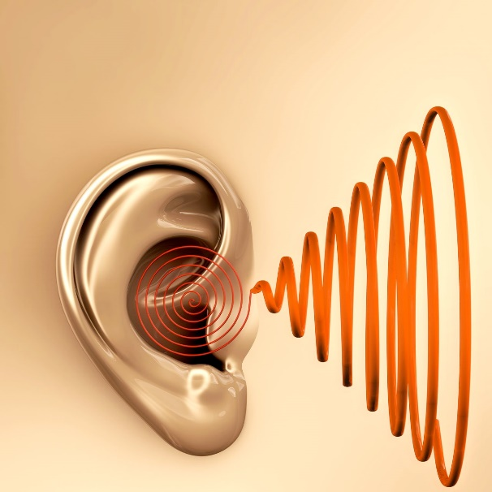

What time of sounds you include in your stories?

What are your favourite sounds? What music do you like?

Gill’s sound tape
1.

2.

3.

4.

Sound words

