Inkpots sense sheet 3: taste
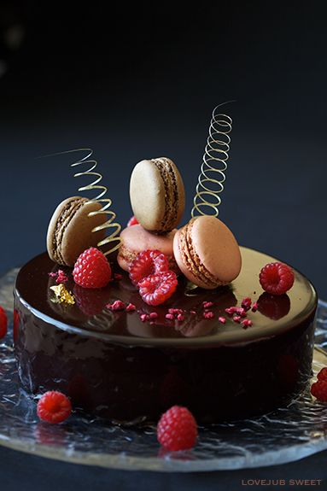

Do you ever think about including how food tastes in your stories?

Gill’s taste test:

1

2

3

Taste words:

