Inkpots sense sheet 1: sight
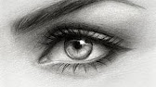
What’s your favourite sight of interest? Do you like the Windmills or going to the sea?

What would it be like if one of your characters couldn’t see very well – how would they cope in the story?

What would it be like if you had colour blindness?

How do you describe eyes – ‘his eyes are blue’ – make that more exciting

Sight words:

