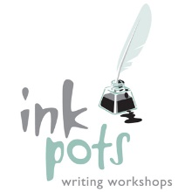

INKPOTS WRITING WORKSHOPS
Please complete this form and return to Gill. Thank you!

Child’s name: Hannah Bryan__
Year Group___Year 5________________
Parents’ email____jo.l.bryan@gmail.com_______________________________________
Parents’ contact number________07725566475____________________
Who will collect your child from Inkpots?____Jo Bryan (Mum)___

I give permission for photographs of my child to be taken at Inkpots Writing Workshops. These photographs may only be used for publicity purposes on the Inkpots website and related social media platforms. I further give permission for my child to have refreshments at Inkpots workshops.
Details of allergies/ food intolerances: _Hannah has a nut allergy so no nuts please. (However, she does love cake!)

Signed______Jo Bryan____
(parent/carer)
Date_________08.12.16__________

